A group of people walking in front of a building

Description generated with very high confidence

What does the Art Museum want?

Manipulated photograph by Heather Vantrieste and Sean O'Rourke

**A Session with Art: “Making a Classic Modern”**

**(or Wrestling with a Crisis in Faith)**

by Sean O'Rourke, AIA

Doctor— Hi, Art. Come in. Come in. How are you doing?

Art Museum: Hi, Doctor. I am doing fine, thank you.

Dr. — Your expansion plans are proceeding smoothly. I see the huge model exhibited upstairs and some of the changes are slowly being revealed. You must be excited?

Art: I am excited; it is big news. I am happy despite the internal discomfort. But Frank Gehry’s “gash” in the front steps is causing me angst. Maybe we can start with this today? I am still anxious about it.

Dr.— I appreciate your concern. Though I don’t want to poke the potentially deep wound so fast. Can we go back a little in time. Can we talk about some history?

Art: I love history, you know that.

Dr.— I have a photograph here of your one pediment completed with the sculpture group in it. What do you feel when you look at this?

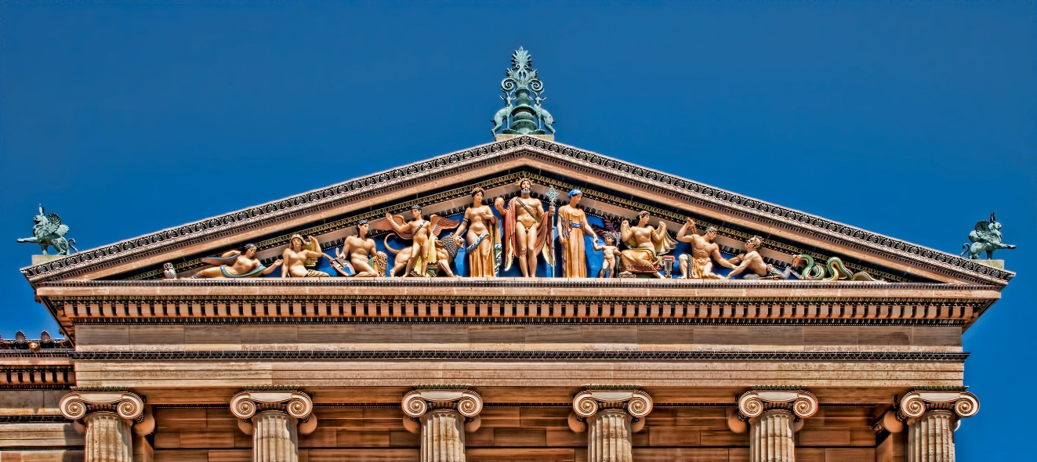

Image copyright: Anita Bower

Art: What do I feel? I love it. Jennewein did a beautiful job with this one, “Western Civilization” he called it. And do you know the story of Betty, the retired secretary, she bequeathed funds in the 90’s to add another group at the other pediment? It was so thoughtful of her, totally unexpected by me--what a gift!

Dr.— What happened? Where is it?

Art: Well, it wasn’t enough money to do it. So the official story is that they are holding the money for building improvements.

Dr.— How do you feel about this? Aren’t all the other pediments empty?

Art: Well, it bothers me. Seven of them are empty—just plain brick. I mean the first sculptural group wasn’t installed for years after I was completed. The pediments were designed to hold these sculptures and I feel incomplete. I understand they are expensive and garages need to be built and loading docks constructed, master plans paid for, but they seem to have forgotten about this. Or they don’t want to do it. But I feel it every day, it is like missing favorite jewelry.

Dr. — You are self-conscious about it, I can tell by how you are squirming about.

Art: I am naked! I can see where you are looking, how do you think I feel? Jewelry both embellishes and clothes the body-I know my self-confidence isn’t what it should be. I am a classical building without ornament. How should I feel?

Dr.— Why do you think they are not trying to remedy it?

Art: Things cost money, infrastructure that serves the visitors and get the work in and out is important. A modern vision that captures the modern visitor is critical for art museums today. I can’t survive without these expensive capital projects. That’s the story.

Dr.—And . . . ?

Art: Honestly, it doesn’t feel right to me. Conveniently, Gehry has an idea to turn the brick into glass. Open them up as windows.

Dr.— And. . . ?

Art: I don’t know what to think. Maybe I am old fashioned. Maybe they think the sculptural groups are superfluous, a little too colorful or tacky, no longer popular. I don’t know. I can’t hear all the whispering. Maybe some people don’t like me as a classical building-they want me to be something I am not. I wonder why they can’t have the sculptures with windows behind them?

Dr.— This is obviously bothering you. Let’s go someplace else with this. Do you recognize these photographs?

A person standing in front of a building

Description generated with high confidence

George Krause “Fountainhead” 1970 (copyright George Krause)

A picture containing indoor, building, wall

Description generated with very high confidence

Art: Oh, yes. I own a copy of George Krause’s “Fountainhead.” I think he took it right out front in my fountains next to the steps. And the other one is when the fountain was working and city kids used them. These bring back memories.

Dr.— What kind of memories?

Art: Oh, I loved people crawling all over the fountains. I felt useful and alive. I was interacting with the community and the city in a way I wasn’t used to. I felt like I had a purpose--a certain classic grandeur and yet an informal playful energy and vitality. It was popular place in the 1970’s--with the families and children.

Dr.— What happened?

Art: I don’t know. The fountains were turned off. And the kids stopped coming. But I can imagine the story. The fountains weren’t designed to be swimming pools.  It was dangerous too--the risk and liability! And truth be told, what did this have to do with “Art”? I can imagine they didn’t like these kids roaming all over my front steps. It was popular while it lasted, but they didn’t come in to see my collections.

Dr.— Did that bother you?

Art: Well I can imagine it might have bothered some people. At the time I don’t think we tried to welcome a more diverse crowd into the museum.

Dr.— Well you had a popular show with great attendance earlier [in 2012] with Zoe Strauss.

Art: What about her? She had a great exhibit. It brought so many people into the museum! I loved it. And her story was so uplifting. She was hanging photographs underneath I-95 in South Philly and next-thing-you-know she’s hanging work on my walls. It is an impressive story.

Dr.— But?

Art: No hesitation; the show was a big hit, especially with a crowd I don’t always attract.

Dr.—What do you mean?

Art: The demographics was younger, a few more tattoos, piercings, and hair color surprises. But it was popular. And she did it here in our city. She had the credentials that validated the work. It was great. You saw the show, what did you think?

Dr.— Well, some of the photographs were good. Others, honestly belonged under I-95.

Art: Did you read the catalog? Yes, some of her photographs were snapshots, but the collective body of work fell right into the long tradition of street photography. The catalog spelled it all out, the classic but popular. You should read the catalog it clearly validated her work.

Dr.— What about this photograph of the Rocky statue on the top of the steps?

A group of people standing in front of a building

Description generated with very high confidence

Art: I love Rocky too! I know you might think otherwise, as classical and as rooted in tradition as I am. But the story couldn’t be any more classical in its “hero quest,” right? I loved him up there. So many people climbing the steps to be photographed with the sculpture. I give Rocky’s sculpture credit for reminding the city what a great set of steps I have. I lost the energy of people using the fountains, but now these stairs are so popular. Though I understand how some people thought it was controversial to place him at the top of the stairs.

Dr.— Why do you think that? Wasn’t that where he posed?

Art: Yes, of course. But it was installed there for one of the Rocky sequels. It was a film prop not a piece of “Art.” That axis along the Parkway is pretty important, from all the Calder family’s work on City Hall, in the Logan Circle Fountain, and the mobile inside. Then inside and up the stairs is Saint-Gaudens’ “Diana.” It is heady company. I mean who was the artist that made the Rocky sculpture--does he deserve the same validation?

Dr.— There is a lot of art on this Parkway axis, isn’t there? Not all of it as well loved as the ones you mention.

Art: Yes, yes. The LOVE sculpture is very popular, but there seems to be one in every other city. Washington’s Monument at Eakins Oval--which I have heard people complaining gets in the way of the concerts. And even Lipchitz’s tiny one at my front steps; no one remembers it.

Dr.— So these are all “Art” while Rocky isn’t?

Art: That’s the story! Rocky is a fictional character from a movie endlessly re-run on Saturday afternoon network TV. It is in the way at the top of the stairs. People run the stairs re-enacting Rocky’s climb to ascendancy. They don’t want to run up the stair and find Rocky at the top. They are Rocky: acting as he did. The new home for the statue over on the side is much better. There is a lot of good “Art” work along the Parkway. My stairs are the iconic element that mean so much to people. It shouldn’t get clogged with props. That’s the story.

Dr.— You said “my” stairs, not Rocky’s stairs?

Art: Mine! He appropriated them. He took them from me to make money from his crass movies. The movies are not “Art.” They aren’t even very good.

Dr.— But the movies--especially the first one--resonate with a lot of people. The myth of the working class man rising to overcome adversity to become a champion through hard work and strong character is an attractive myth. The movies seem very popular. And so many people visit the Rocky sculpture and run up the stairs.

Art: I know, but we are talking about my stairs now. . . .

Dr.— But people have said that Rocky’s sculpture at the top of the stairs could be Philadelphia’s version of Copehagen’s “The Little Mermaid” or Brussel’s “Manneken Pis.”

Art: Not on my stairs.

Dr.— And so, if they are your stairs…., this is why you are anxious about Gehry’s idea—cutting a gash into your stairs?

A picture containing building, floor, table, indoor

Description generated with high confidence

Art: Well, he has had worse ideas . . .

Dr.— What do you mean?

Art: Have you seen some of his buildings? I hear he crumbles up paper, hundreds of pieces and picks one out and tries to build it out of a very expensive metal.

Dr.— Gehry has been insistent that he doesn't want to make a splash here. The window into the  museum below the plaza, the outdoor space, and stair changes seems harmless enough, what is the fuss?

Art: Look at the model! It will be a drastic change. I am nervous it will destroy the attraction of the stairs. People might stop visiting my stairs just like when the fountains were shut off. I like the design of my stairs. I like their rise and run—their materiality and monumentality. They put me on a pedestal that seems appropriate to my position. And I love that everyone uses them.

Dr.— So you don’t want Rocky on the top of the stairs and now you don’t want Gehry to change them . . . .

Art: Well, if I were honest with myself, where the Rocky sculpture is now, is stupid. If I can live with Lipchitz’s piece on axis, which I don’t find particularly attractive, I could live with Rocky.

Dr.— And Gehry?

Art: I don’t trust Frank to get it right. Rocky grew out of a groundswell of public affection for the underdog. It is a theme that resonates with, and celebrates, Philadelphia. Frank is all about trying to be hip and cool.

Dr.— And that is wrong?

Art: Doc, what do I know about hip? I am a classical building, anything but exactly cool. And it isn’t the first window to cause such a stir. I know my friend Whitney in New York got a lot of flak for her windows years ago. But they became part of what Whitney was known for. My window may too. And it is more than a window, it is an outdoor room.

Dr.— But you are afraid the window and room will destroy the stairs as so many people have come to know and experience them.

Art: Well, I am a classicist so what do I know about modernity? But it feels wrong to me, the wrong proportion, the wrong idea. This design gesture will supposedly make the stairs better. But when I look at the model it looks too large. I lose the stairs to the sides. It will supposedly bring the stairs back into the experience of the museum.

Dr.— And you don't believe this? The stairs seem to belong to the city now, and Gehry’s design could destroy that relationship?

Art: Well, of course, that is not the intent, but I worry. The window and outdoor room are meant to re-engage the city and museum. It will bring the classic off the hill and back into the city. That’s the official story and I am sticking to it.

Dr.— Well some people who saw the models claim that you won’t be able to see the city from the window anyway. Is this true?

Art: I don’t know, I hope they get it right. It would be awful if all you can see from the inside is the top of the skyline. Anyway it is just an idea now. The story is the “window and gash in the stair” is only an idea; anything can happen.

Dr.— But we know better than that, don’t we? They moved the Rocky statue off the stairs, but the people still come to visit the sculpture. And the city still engage with the stairs in so many different ways.

Art: Yes, I love the interaction, but if they could come in, too. They need to engage with me! I don’t want Frank to ruin my stairs! A lot of these people are using the stairs but not coming in to visit!

Dr.— Even at the expense of that connection with the city? When you shut the fountains off, the people stopped coming. This could happen again. How is the ‘window and stairs’ any less a prop than the Rocky sculpture?

Art: It is Gehry’s prop, and he is cool-a recognizable “ART” star with credentials--not like Rocky. Gehry’s window and room will replace Rocky’s stairs and provide a great experience with my art and the city. I hope.

Dr.— Millions of dollars have just been spent eliminating another partially submerged room that was meant to connect—in its case—connect the subway with the city and City Hall: Dilworth Plaza.

Art: I know, right? I remember how City Hall was so excited about it originally, but it didn’t work at all. All good intentions but it failed. Gehry’s room could be just as cold and forlorn. It could destroy my stair and its attraction to all the people who use it now.

Dr.— Well, you are not the first having problems connecting with a citizenry that finds more meaning in popular culture than in what you hold dear.

Art: I know, some people are claiming that they are going to re-name Lipchitz’s sculpture at my front door “Frank Wrestling with Classicism.” While others want it renamed “Gehry Strangling Classicism”.  Regardless of what people call it, it still isn’t very popular—no one climbs my stairs to emulate it or to be photographed alongside it, yet it can stand on axis with my front doors.

Dr.— Unfortunately that is all the time we have this week.

A statue in front of a building

Description generated with high confidence

**Sean O'Rourke, AIA**, is an architect at Bergmann Associates. He has lived, practiced, studied, and taught in Philadelphia since arriving here from college in 1984.